// Write a Java program to print the multiplication table of a number using a for loop.

import java.util.Scanner;

public interface Multiplication {

public static void main(String args[]){

Scanner scanner = new Scanner(System.in);

System.out.println("Enter a Number to prints its multiplication table : ");

int num = scanner.nextInt();

System.out.println("Mutiplication of " + num + ":");

for(int i=1; i<=10;i++){

System.out.println(num + " X " +i + " = " + (num\*i));

}

}

}

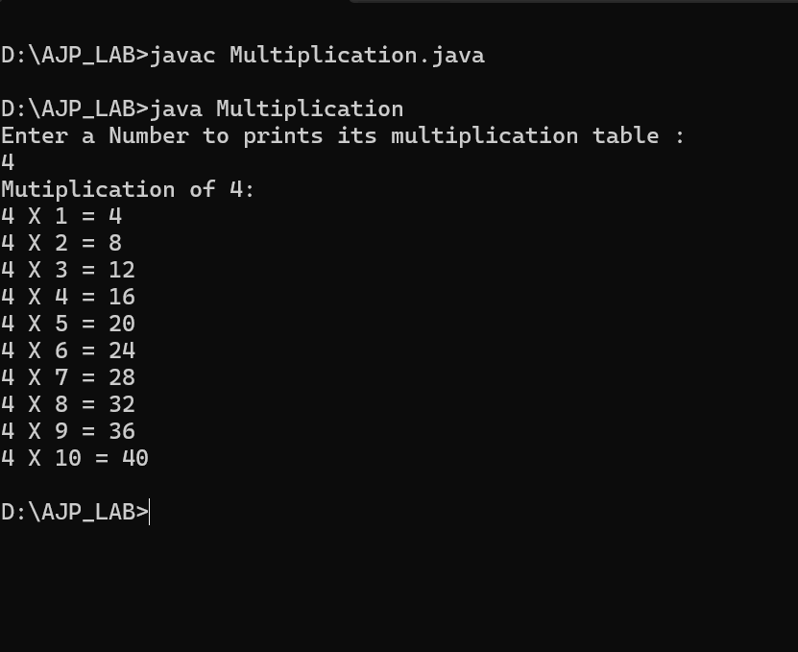

// Write a Java program to reverse a number using a while loop.

import java.util.Scanner;

public class ReverseNumber {

public static void main(String Args[]){

Scanner scanner = new Scanner(System.in);

System.out.println("Enter a number to reverse: ");

int num = scanner.nextInt();

int originalNum = num;

int reversed = 0;

while(num != 0){

int digit = num%10;

reversed = reversed \* 10 +digit;

num = num/10;

}

System.out.println("Reversed number of " +originalNum+ " is : " +reversed);

}

}

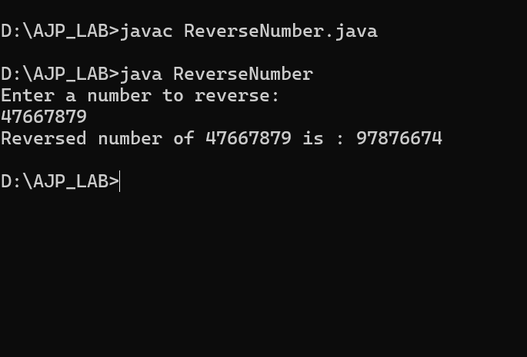

// Create a menu-driven calculator using a do-while loop that supports addition, subtraction, multiplication, and division. The loop should continue until the user chooses to exit.

import java.util.Scanner;

public abstract class MenuDrivenCalculator {

public static void main(String[] args) {

Scanner sc = new Scanner(System.in);

int choice;

double num1,num2,result;

do {

System.out.println("/n--- Calculator Menu ---");

System.out.println("1.Addition");

System.out.println("2.Subtraction");

System.out.println("3.Multiplication");

System.out.println("4.Division");

System.out.println("5.Exit");

System.out.println("Enter your choice (1-5) : ");

choice = sc.nextInt();

switch(choice){

case 1:

System.out.println("Enter First Number : ");

num1 = sc.nextDouble();

System.out.println("Enter Second Number : ");

num2 = sc.nextDouble();

result = num1 + num2;

System.out.println("Result : " +result);

break;

case 2:

System.out.println("Enter First Number : ");

num1 = sc.nextDouble();

System.out.println("Enter Second Number : ");

num2 = sc.nextDouble();

result = num1 - num2;

System.out.println("Result : " +result);

break;

case 3:

System.out.println("Enter First Number : ");

num1 = sc.nextDouble();

System.out.println("Enter Second Number : ");

num2 = sc.nextDouble();

result = num1 \* num2;

System.out.println("Result : " +result);

break;

case 4:

System.out.println("Enter First Number : ");

num1 = sc.nextDouble();

System.out.println("Enter Second Number : ");

num2 = sc.nextDouble();

if (num2 != 0 ){

result = num1 / num2;

System.out.println("Result : " +result);

} else {

System.out.println("Error : Cannot divide by zero!");

}

break;

case 5:

System.out.println("Exiting calculator. Goodbye!");

break;

default:

System.out.println("Invalid choice! please select between 1 and 5.");

}

} while (choice != 5);

}

}

